**LABORATORIES**

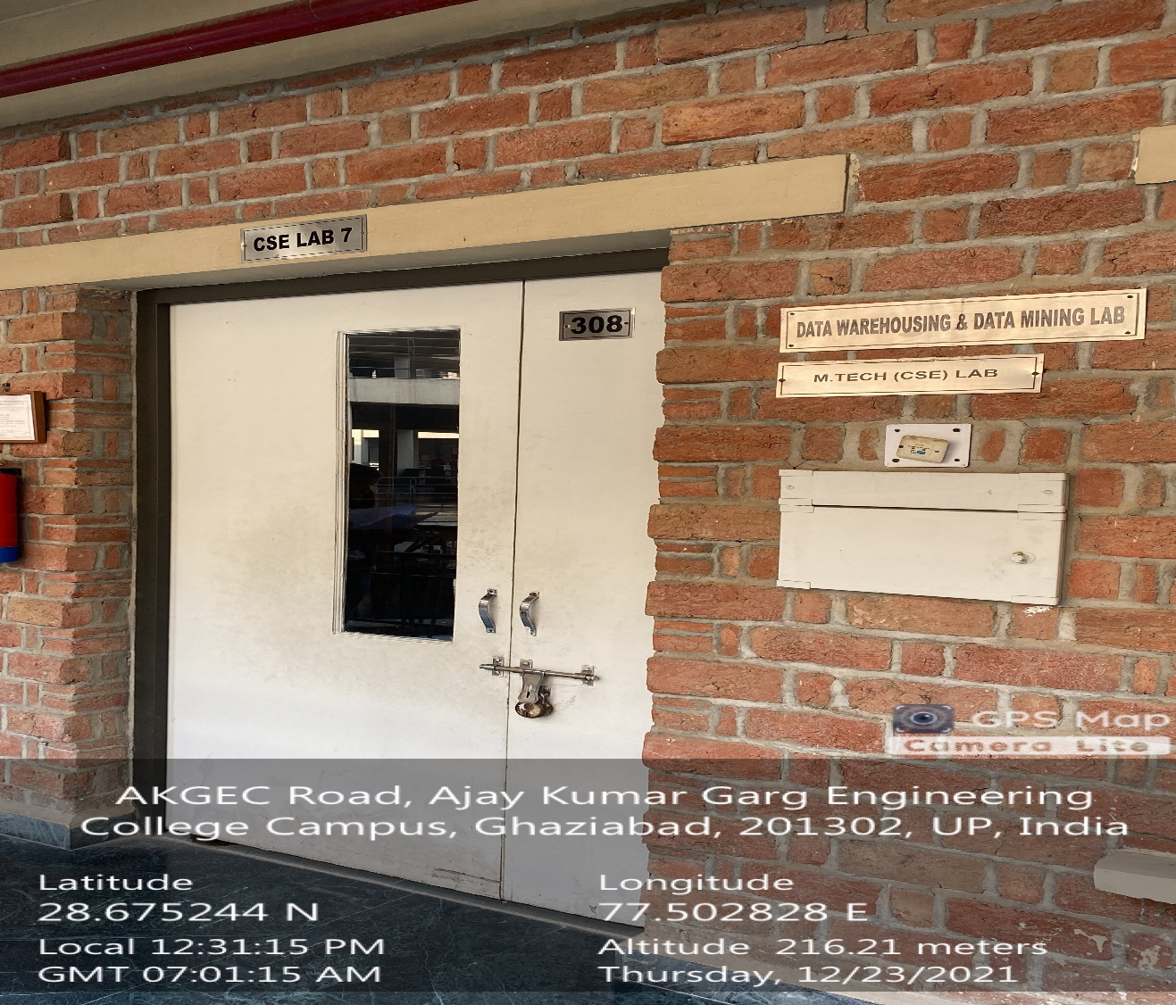

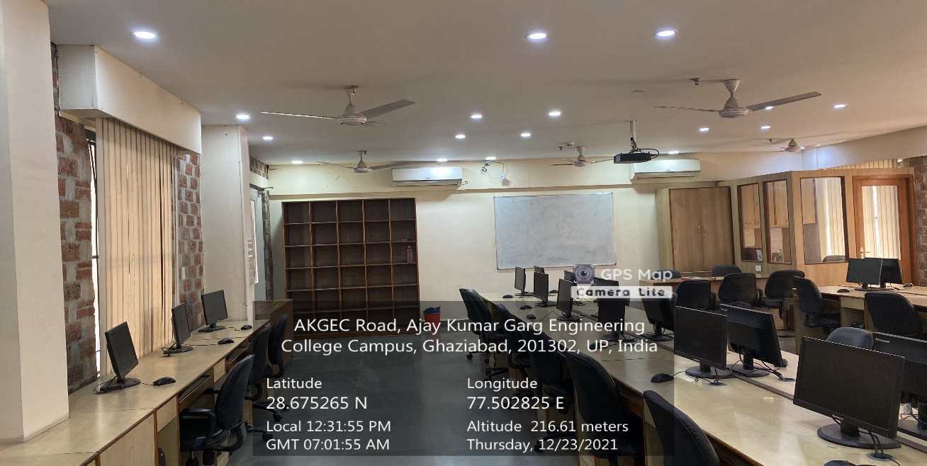

**CSIT Block Third Floor, M.TECH. CSE RESEARCH & DEVELOPMENT LAB**

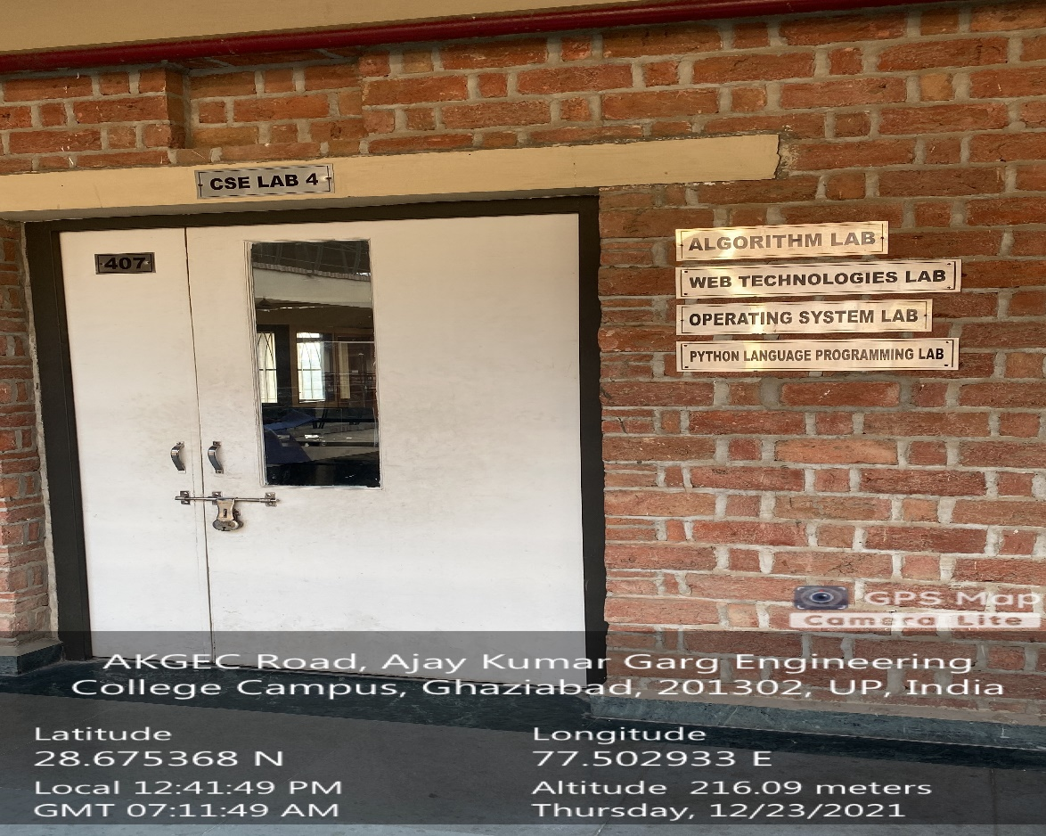

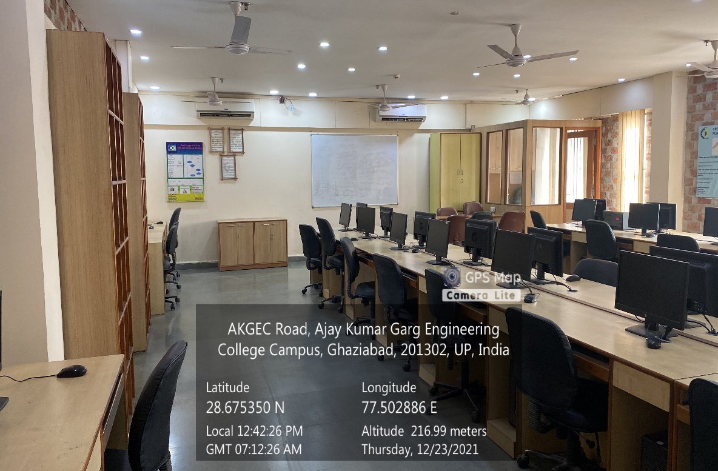

**CSIT Block Third Floor, ALGORITHM LAB**

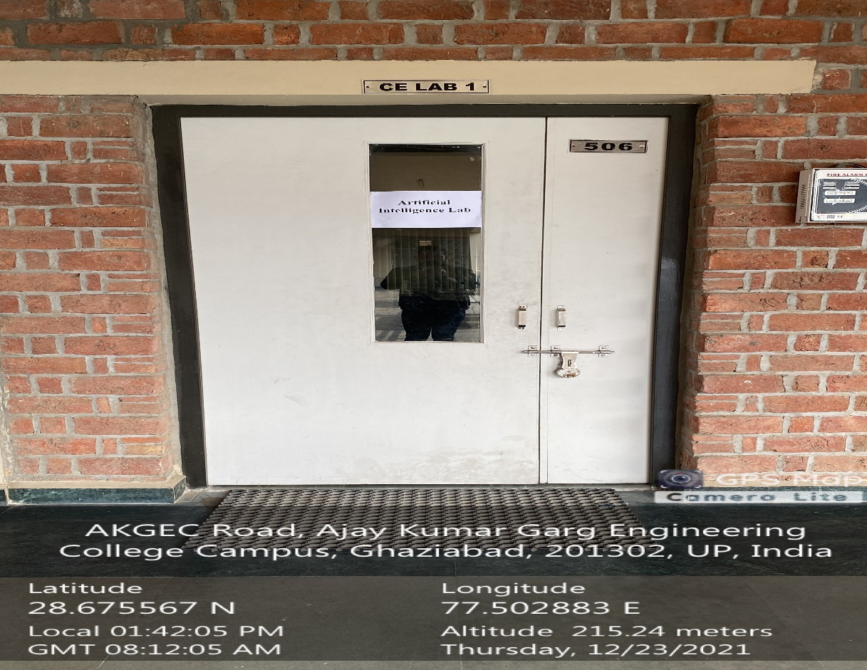

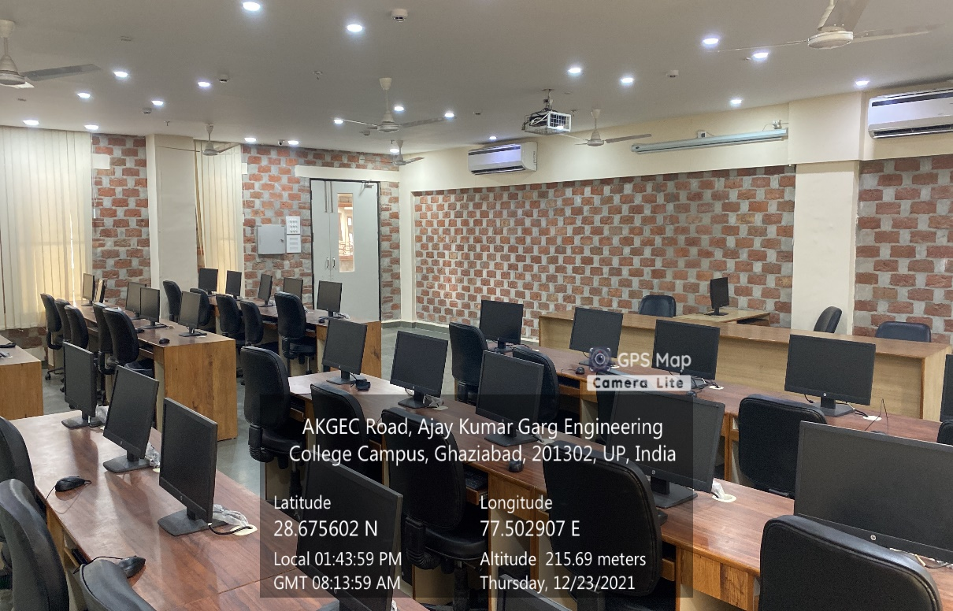

**CSIT Block Third Floor, ARTIFICIAL INTELLIGENCE LAB**

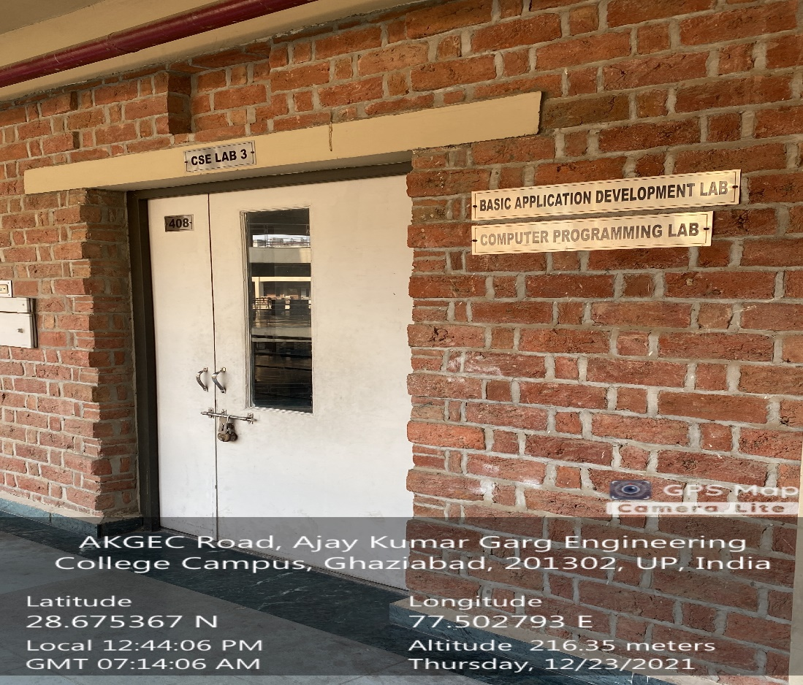

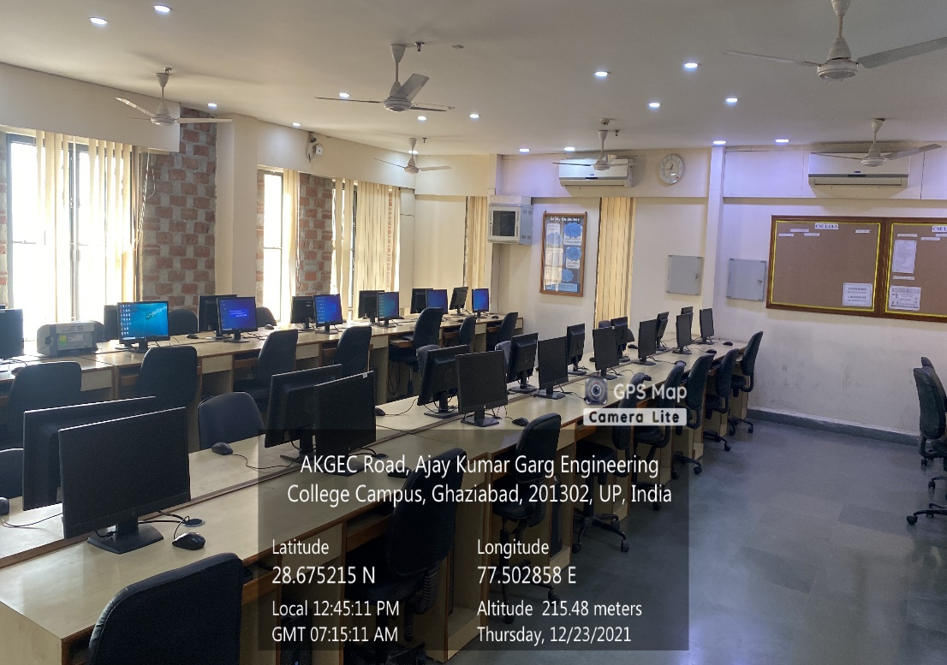

**CSIT Block Third Floor, BASIC APPLICATION DEVELOPMENT LAB**

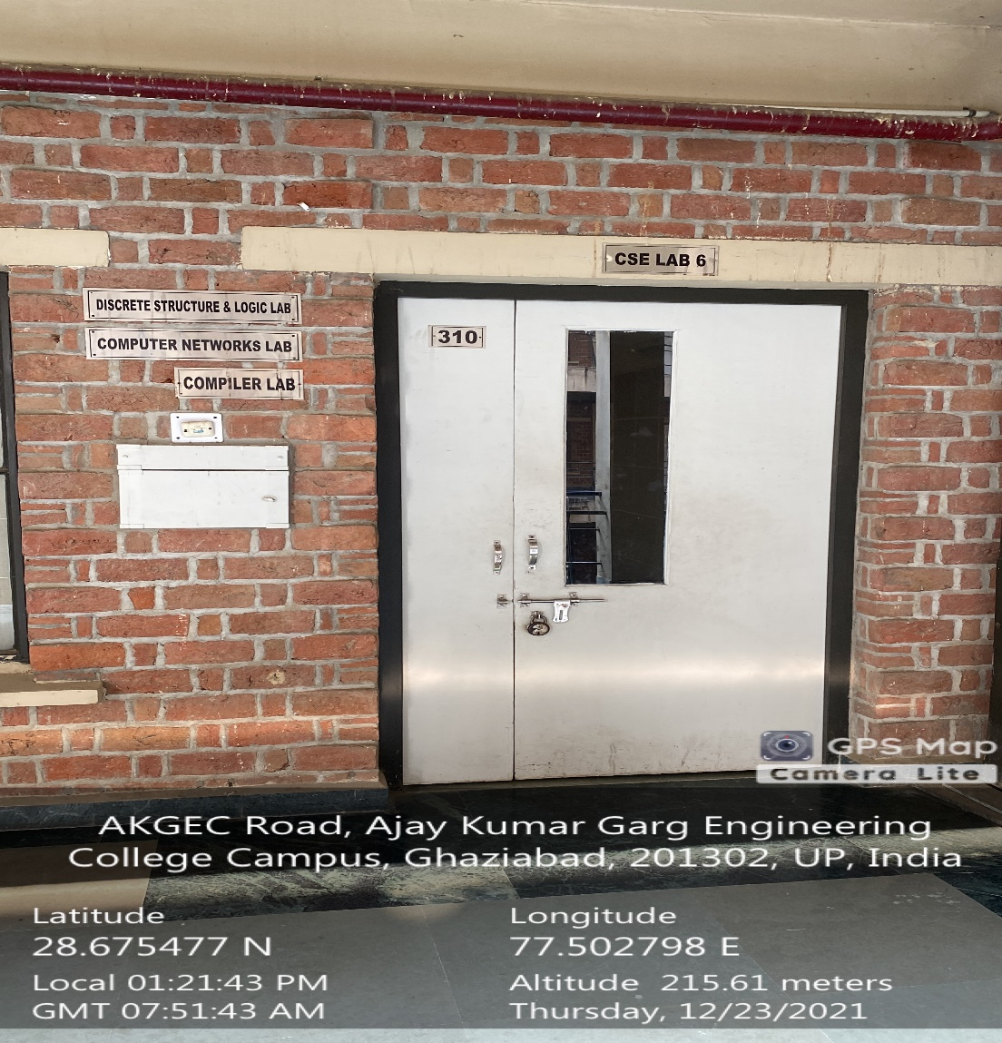

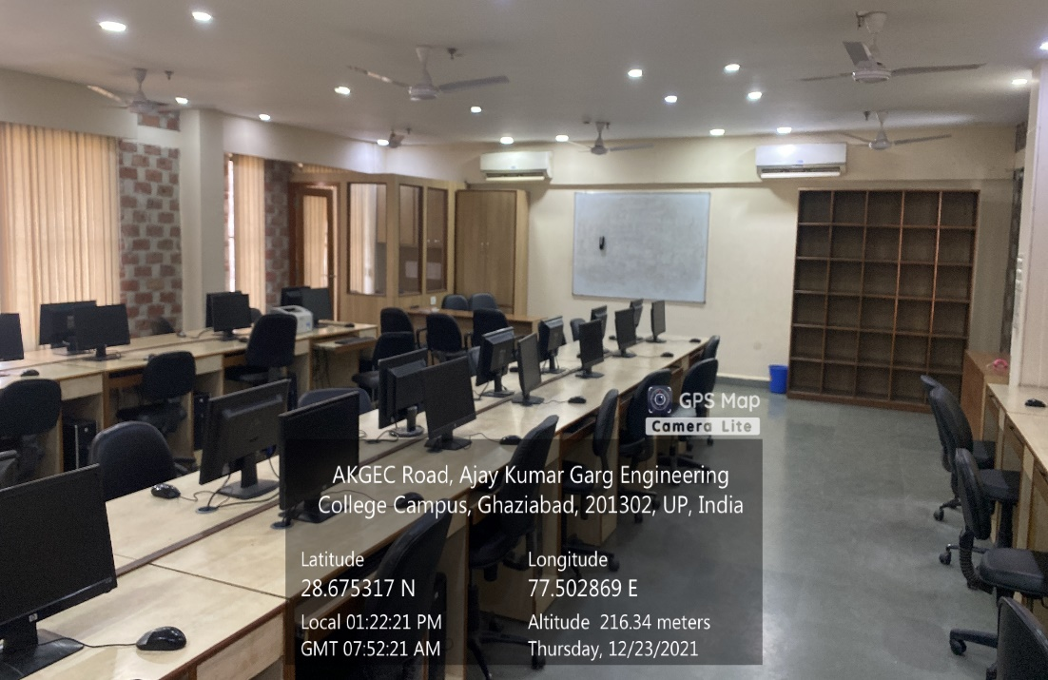

**CSIT Block Third Floor, COMPILER LAB**

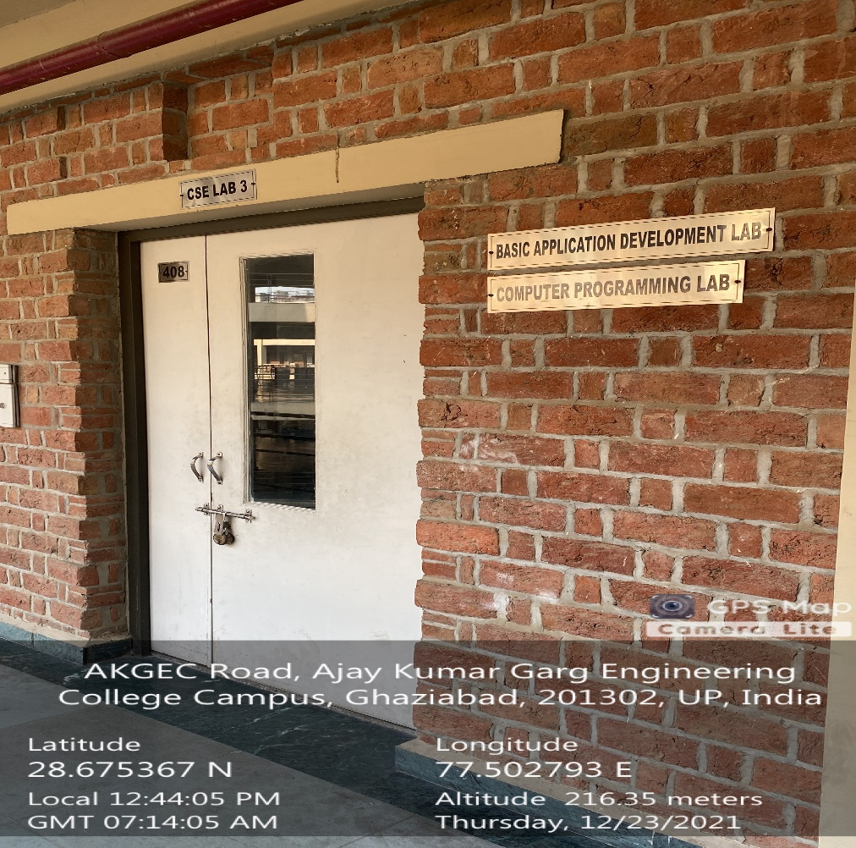

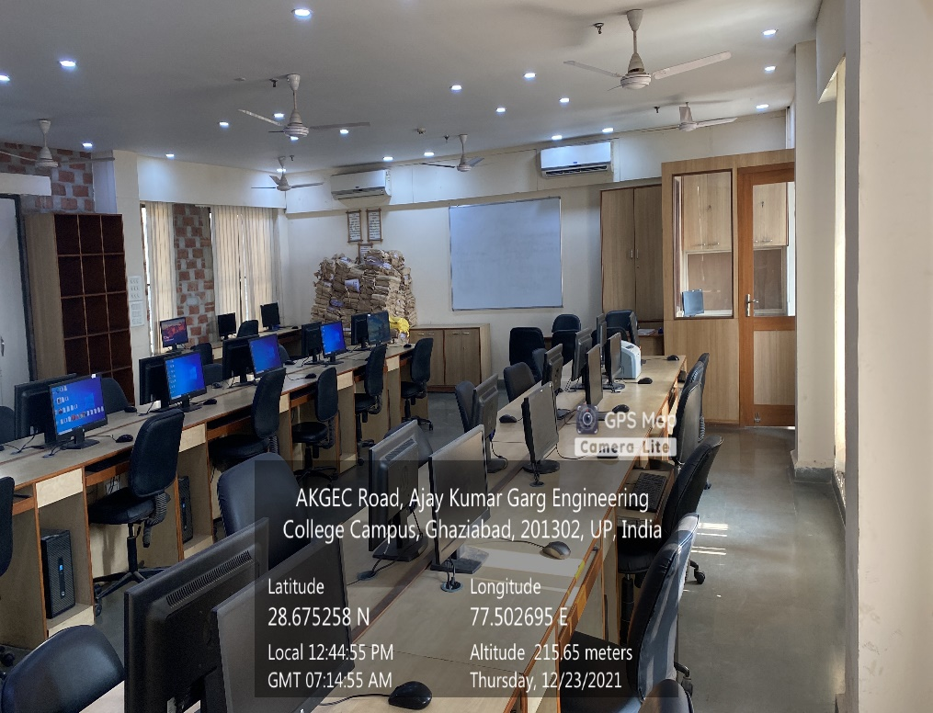

**CSIT Block Third Floor, COMPUTER PROGRAMMING LAB**

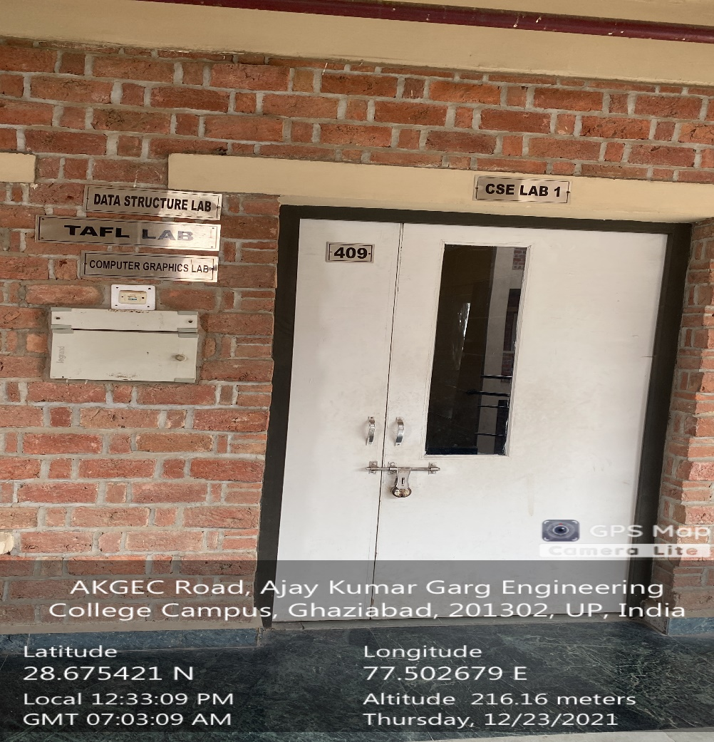

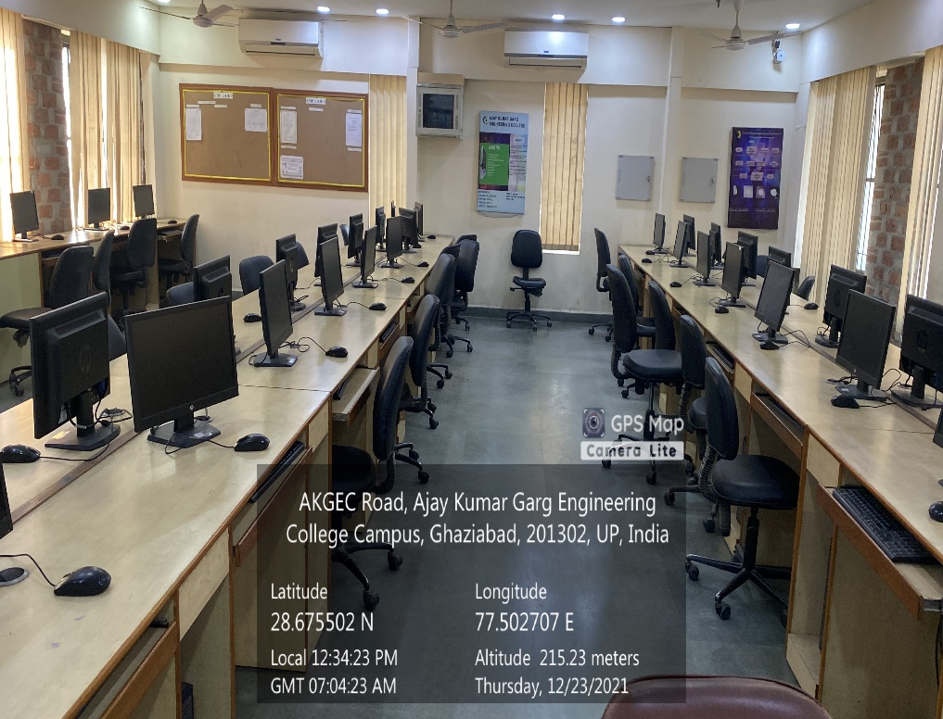

**CSIT Block Third Floor, DATA STRUCTURE LAB**

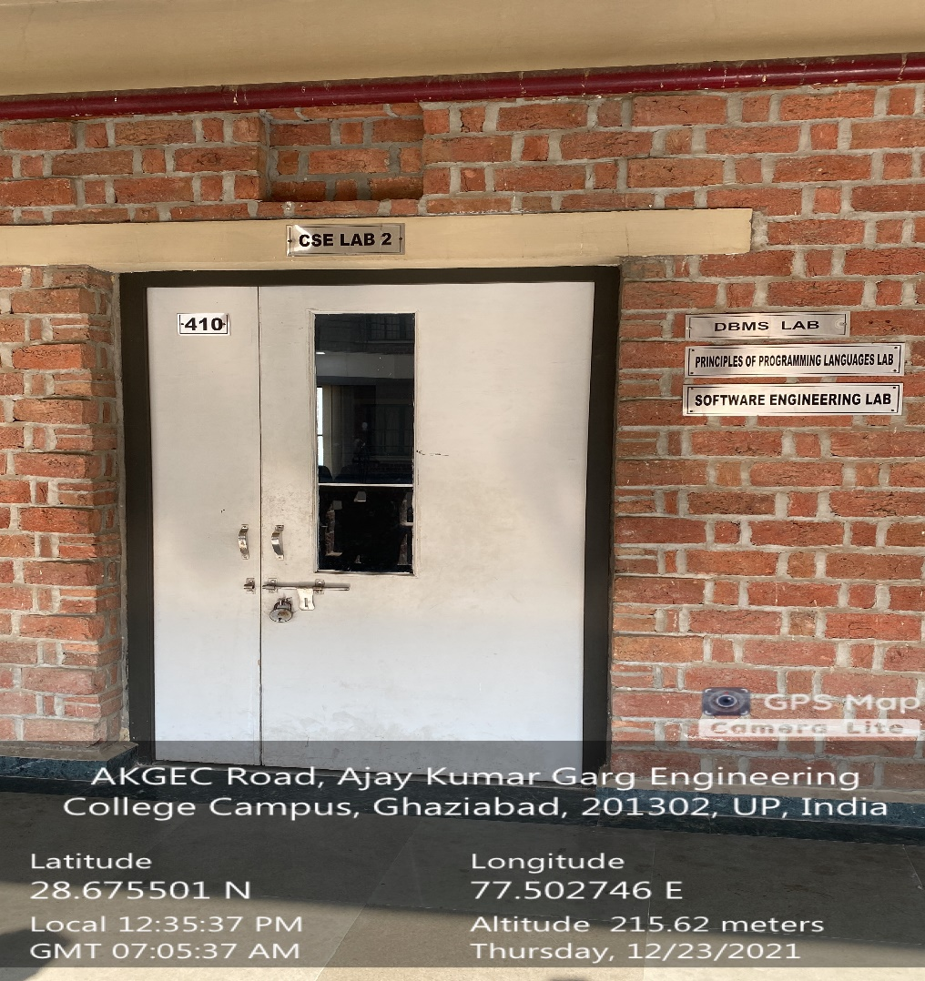

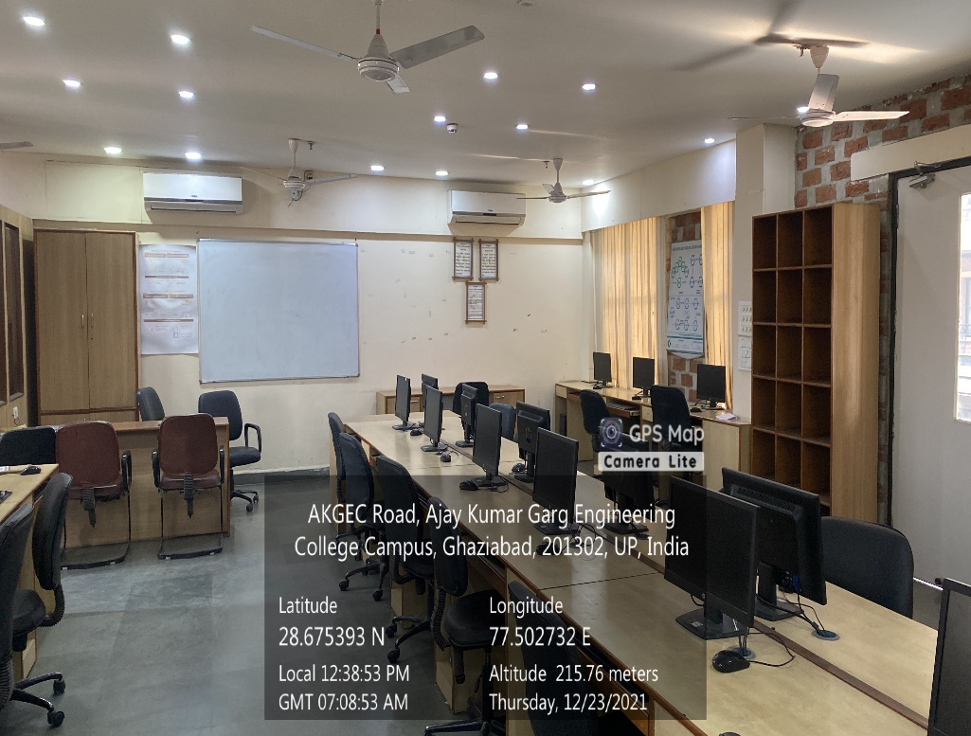

**CSIT Block Third Floor, DBMS LAB**

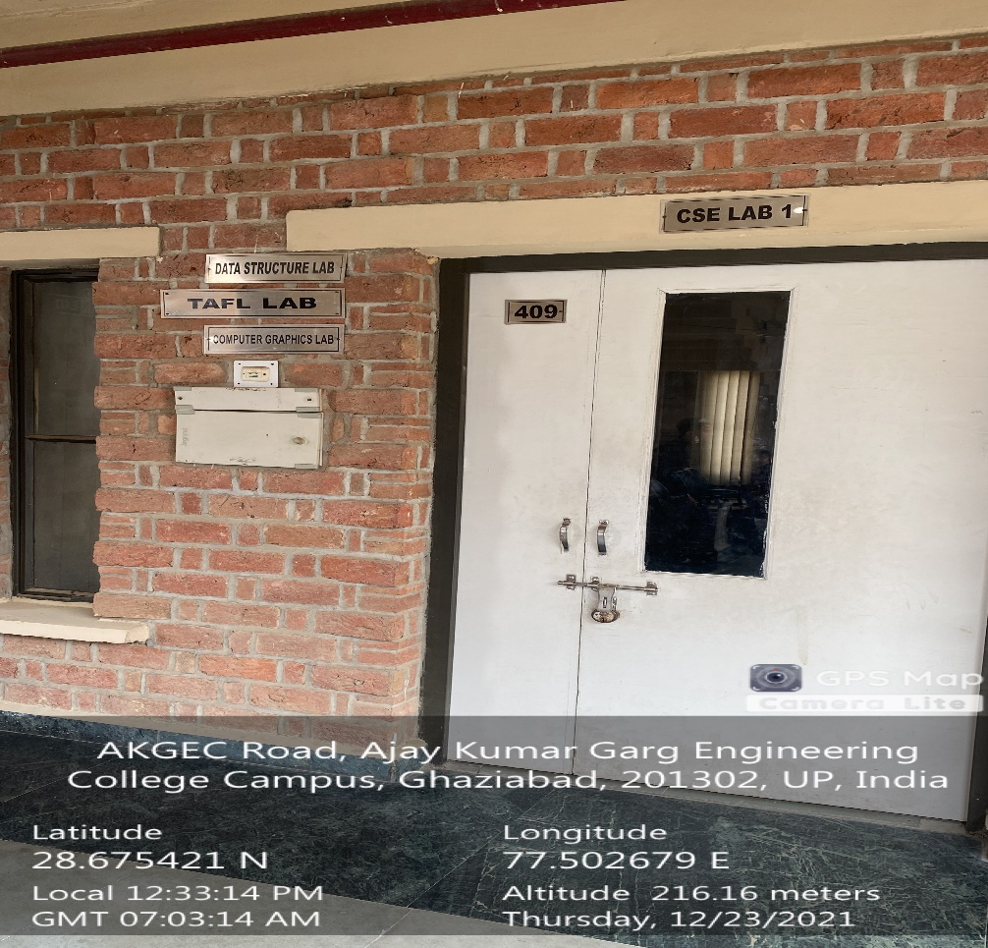

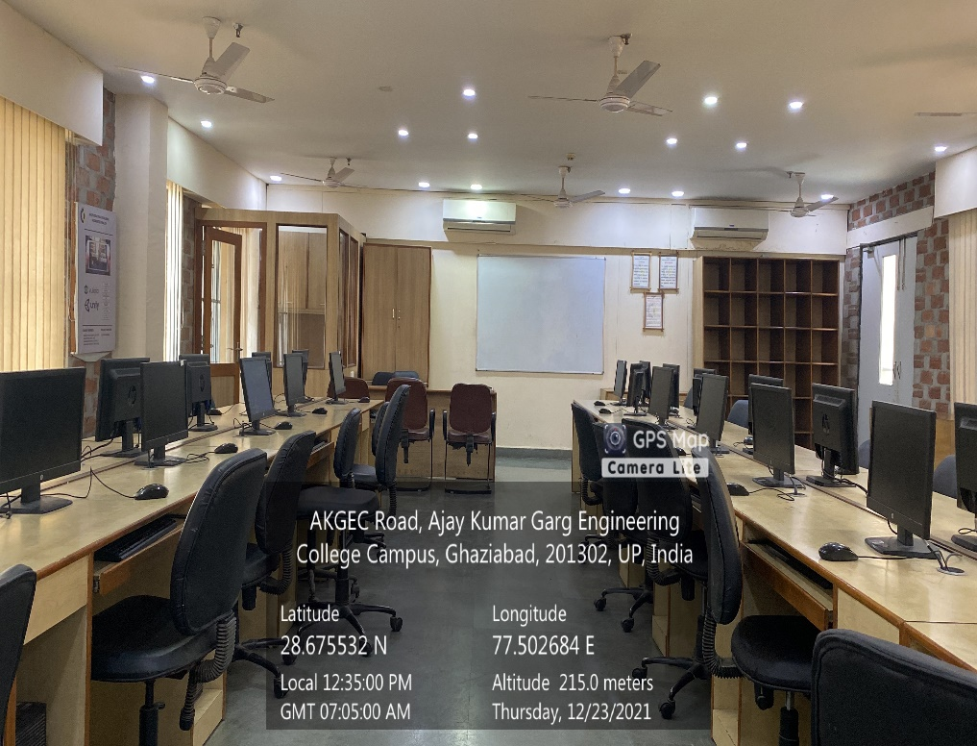

**CSIT Block Third Floor, DISTRIBUTED SYSTEM LAB**

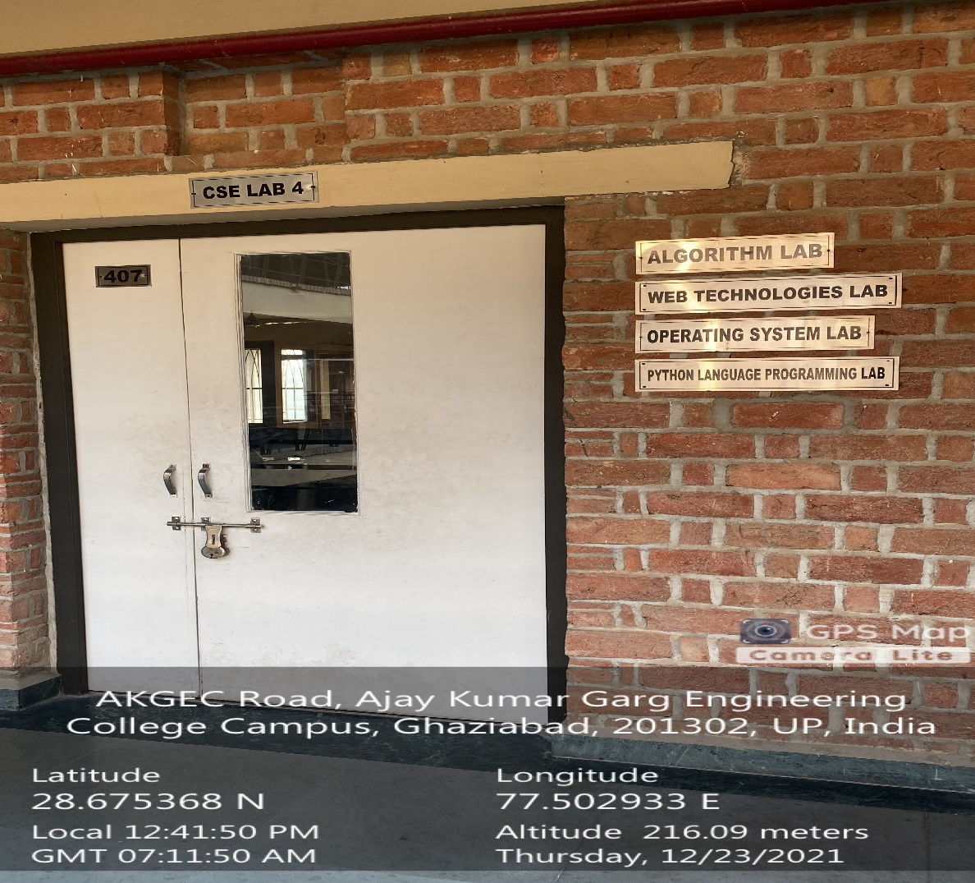

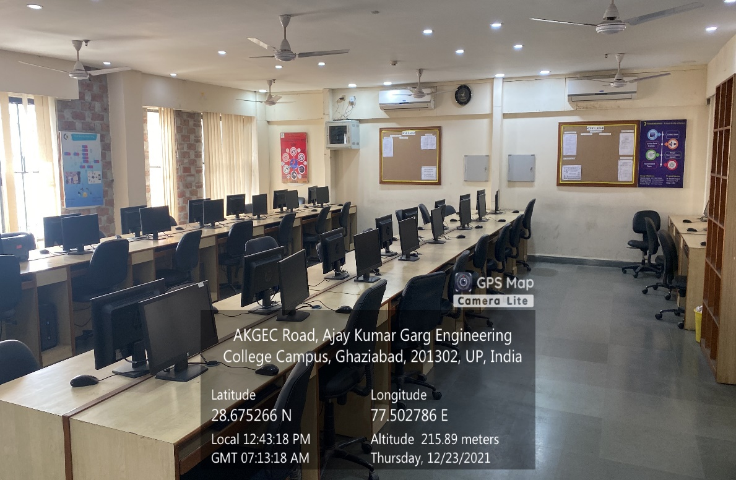

CSIT Block Third Floor, OPERATING SYSTEM LAB



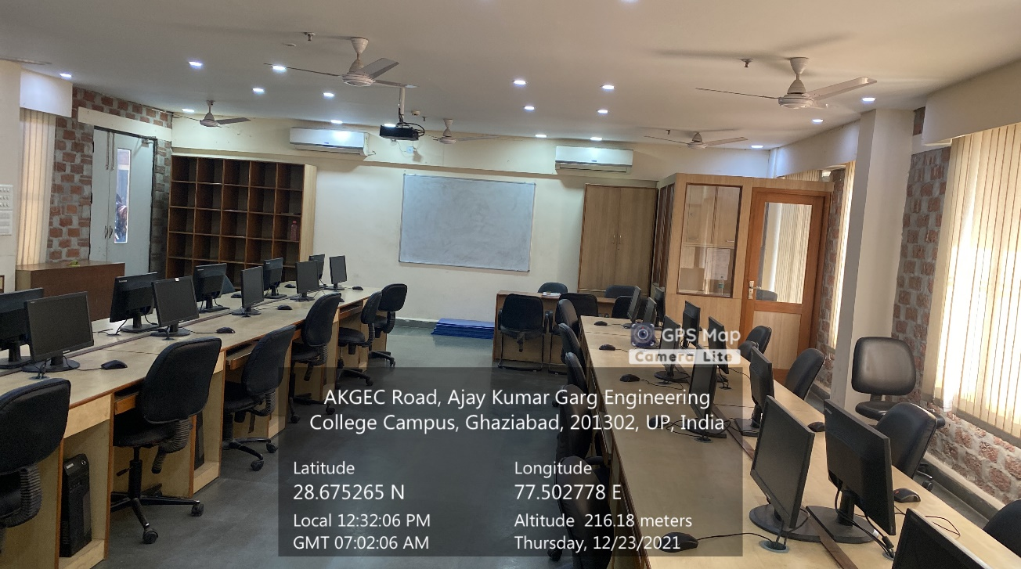

**CSIT Block Third Floor, M.TECH. CSE LAB**

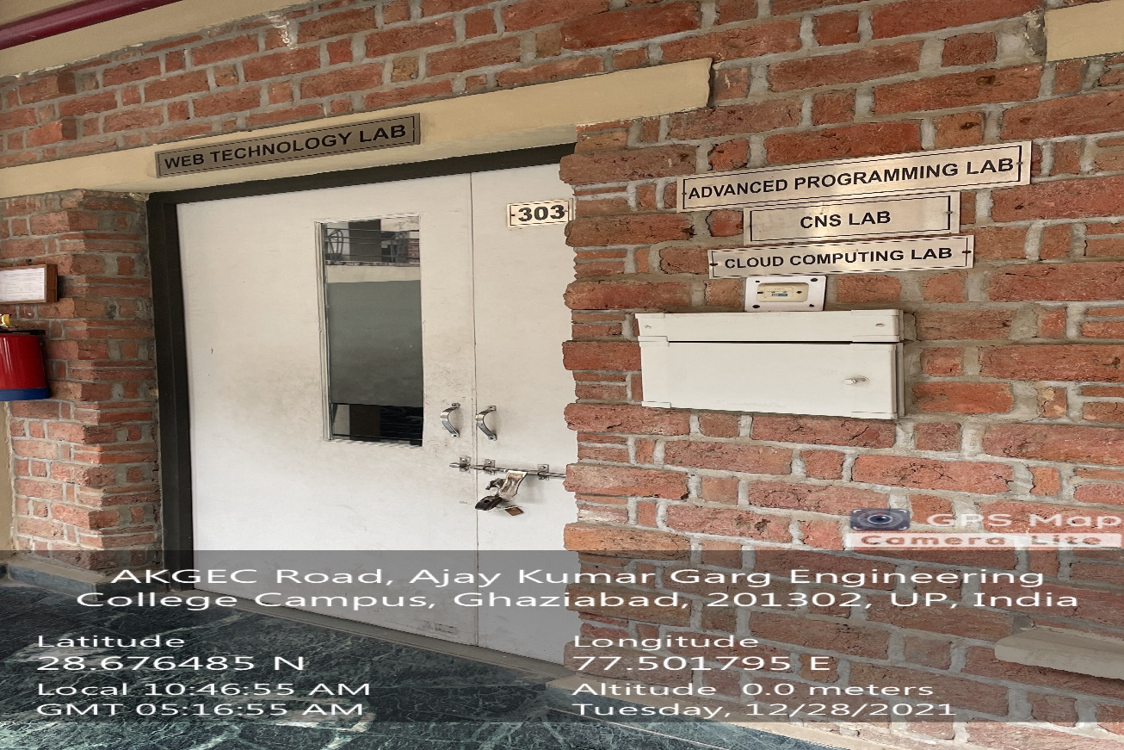

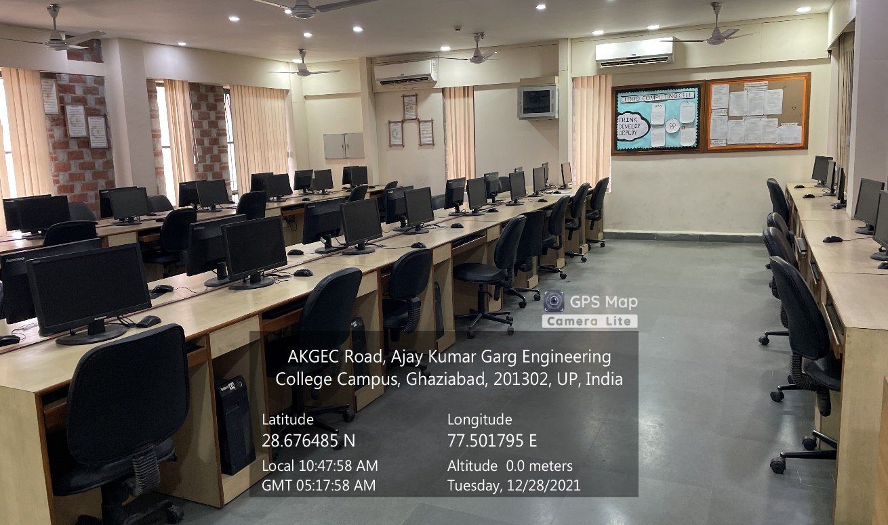

**CSIT Block Third Floor, ADVANCED PROGRAMMING LAB**

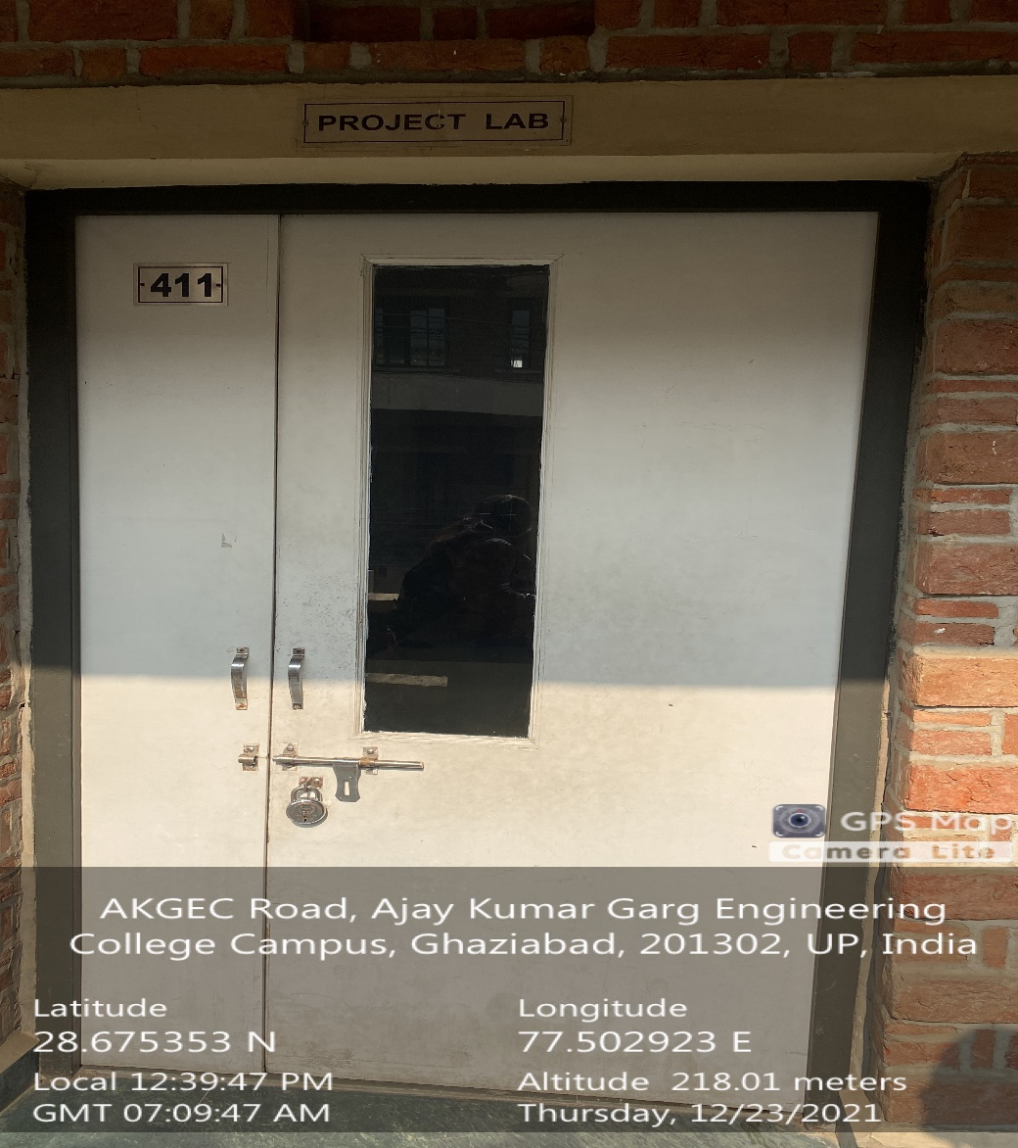

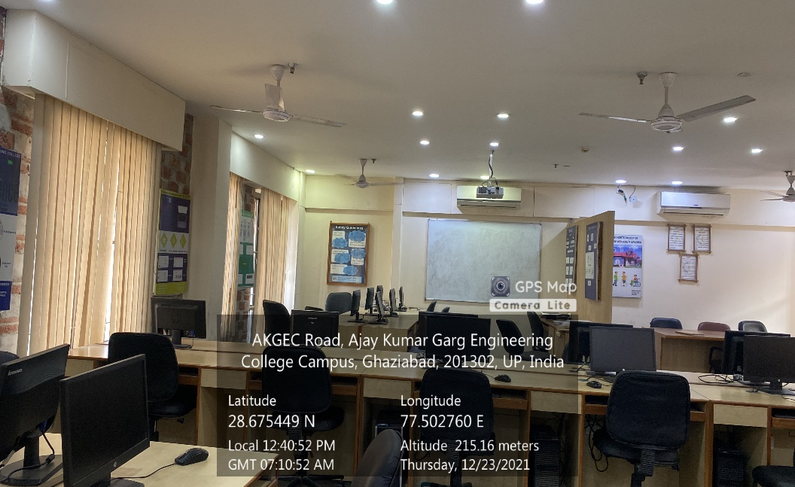

**CSIT Block Third Floor, CSE PROJECT LAB**

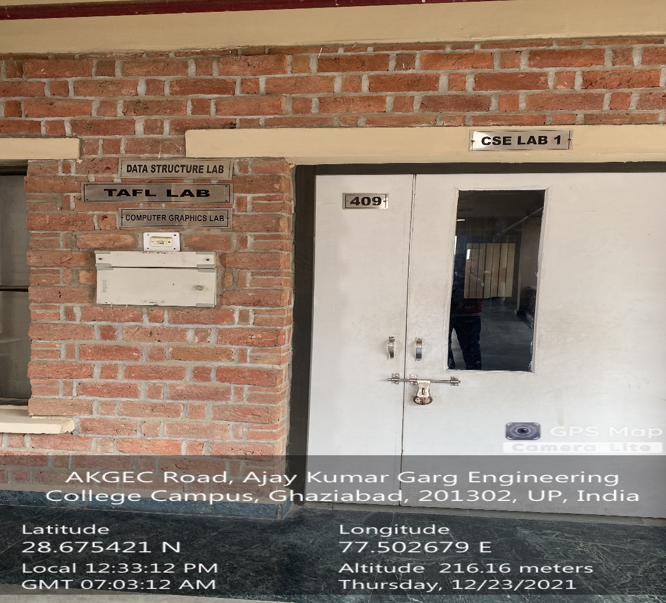

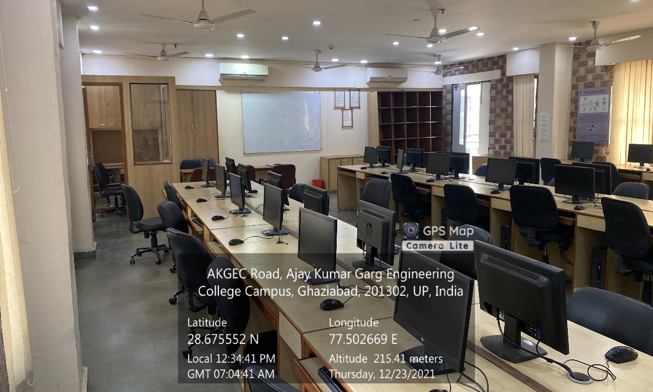

**CSIT Block Third Floor, COMPUTER GRAPHICS LAB**